**ASSIGNMENT 1**

# QUESTION1

## CODE :

#include<iostream>

using namespace std;

int main(){

int a;

cout<<"enter a positive integer:";

cin>>a;

cout<<"the factors of "<<a<<" are:"<<endl;

for(int i=1; i<=a; i++){

if(a % i==0){

cout<<i<<" ,";

}

}

return 0;

}

## OUTPUT :

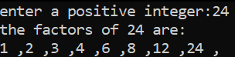

# QUESTION 2

## OUTPUT :



## REASON :

As nothing is given as input in the code. Hence it will print the very first output command when we run it.

# QUESTION 3

## CODE :

#include<iostream>

using namespace std;

int main(){

int b;

cout<<"please give a number:";

cin>>b;

if (10 < b <20){

cout<<1;

}

else{

cout<<0;

}

return 0;

}

## OUTPUT :



# QUESTION 4

#include<iostream>

using namespace std;

int main(){

int n;

int prime;

cout<<"Please enter the number"<<endl;

cin>>n;

for(int i=n; i>=2; i-=1){

for(int j=2; j<=i; j+=1){

if(i%j==0 && i==j){prime = j;}

if(i%j==0){break;}

}

if(prime == i){break;}

}

cout<<"The largest prime is: "<<prime<<endl;

return 0;

}

OUTPUT :

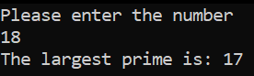

# QUESTION 5

## CODE :

using namespace std;

int main(){

char n1[10];

char n2[10];

cout<<"Please enter the strings"<<endl;

cin>>n1;

cin>>n2;

int p = strlen(n2)-1;

char n3[p];

if(strcmp(n1, n2)==0){

for(int i=0; i<10; i+=1){

n3[p]=n2[i];

p=p-1;}

cout<<"The reversed string is: "<<n3<<endl;}

else{cout<<"the strings are not the same"<<endl;}

return 0;

}

## OUTPUT:

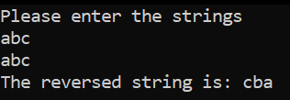

# QUESTION 6

## CODE :

#include<iostream>

using namespace std;

int main(){

int divid;

int divis;

cout<<"enter dividend:";

cin>>divid;

cout<<"enter divisor:";

cin>>divis;

int quot = 0;

while (divid >= divis) {

divid -= divis;

quot++;

}

cout << "Quotient: " << quot << endl;

return 0;

}

## OUTPUT :

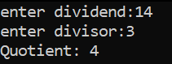

# QUESTION 7

## CODE :

#include<iostream>

#include<string.h>

using namespace std;

int main(){

string S,newS;

int i,j;

cout<<"Enter any string:"<<endl; //input a string from the user

cin>>S;

cout<<endl;

for(i=0;i<S.length();i++){

for( j=0;j<S.length();j++){

if(S[i]==S[j]){

break; }

} if(i==j){

newS+=S[i]; }

} cout<<"sting without duplicate characters: "<<newS; //cout the new string

return 0;

}

## OUTPUT :

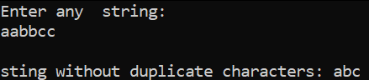

# QUESTION 8

## CODE :

#include<iostream>

using namespace std;

int main(){

int a[] = {1, 2, 3, 4, 5};

int size = 5;

cout << "Array elements before adding more elements: ";

for (int i = 0; i < size; ++i) {

cout << a[i] << " ";

}

int newSize = size + 3;

int* newArray = new int[newSize];

for (int i = 0; i < size; ++i) {

newArray[i] = a[i];

}

newArray[size] = 6;

newArray[size + 1] = 7;

newArray[size + 2] = 8;

cout << "Array elements after adding more elements: ";

for (int i = 0; i < newSize; ++i) {

cout << newArray[i] << " ";

}

delete[] newArray;

## OUTPUT :

